**What is Git ?**

* [Git](https://www.geeksforgeeks.org/git-lets-get-into-it/) is version-control system for tracking changes in source code during software development.
* It is designed for coordinating work among programmers, but it can be used to track changes in any set of files.

#### Git installation and setup

#### ****Step 1:**** The .exe file installer for Git Bash can be downloaded from [**https://gitforwindows.org/**](https://gitforwindows.org/)

#### Once downloaded execute that installer, following window will occur

#### Lightbox

#### Step 2: Browse the location to install

#### 

#### ****Step 3:**** Select on the desktop components that you need to install and click on the Next.

#### Lightbox

#### Then git bash will get installed,launch git bash.

#### Basic local Git operations :

#### Creating a repository

#### Go to any folder(where folder contains the files that should be repoisted) right click on the folder and select git bash here.

#### 

#### **git config --global :** can be used to set user-specific configuration values like email, username, file format, and so on.

#### **git config –global user.name Max**

#### **git config –global user.email** [wheelernancy672@gmail.com](mailto:wheelernancy672@gmail.com)

#### 

git init : This command is used to**create a new blank repository.**

* git init

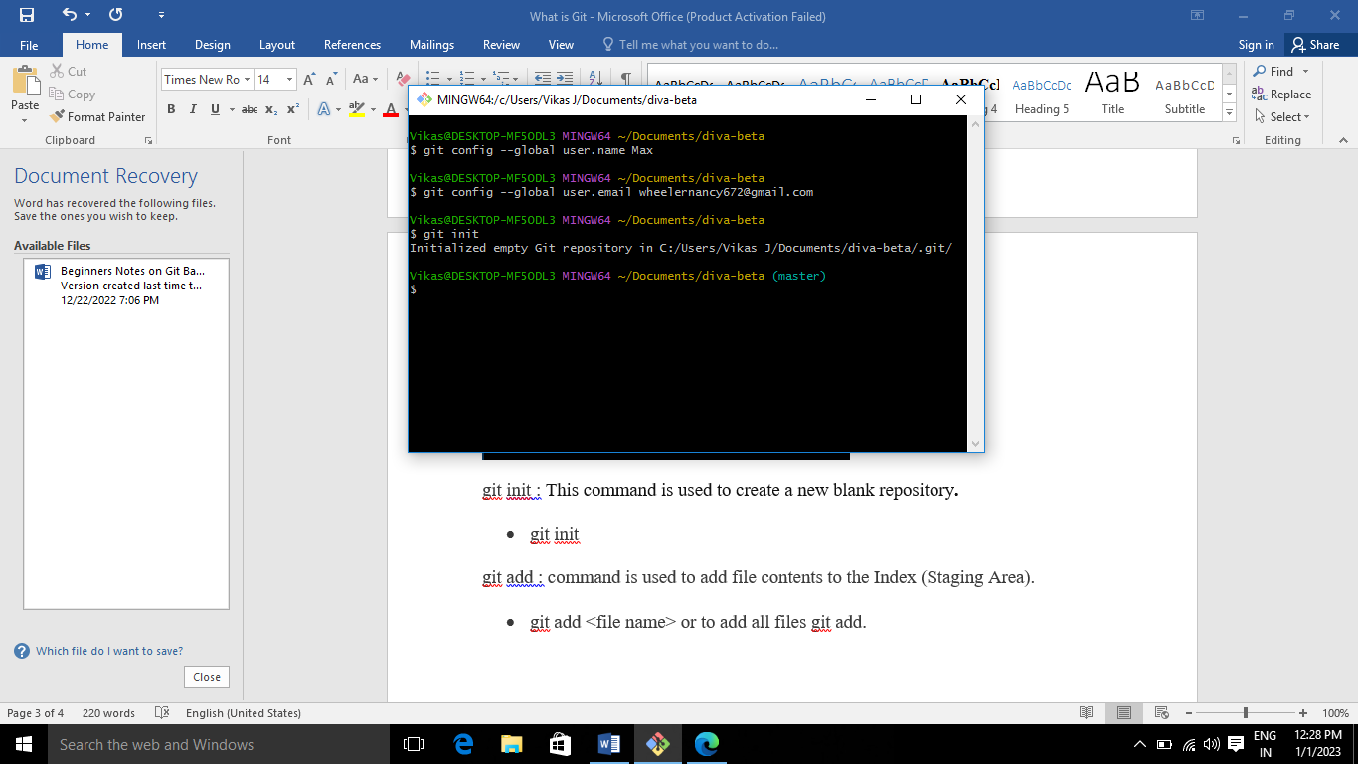

git status : is a simple command that tells us the state of our repository

* git status

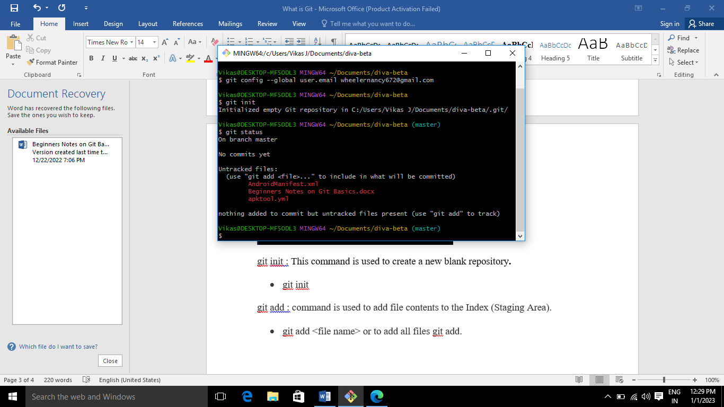

git add : command is used to add file contents to the Index (Staging Area).

* git add <file name> or to add all files git add .

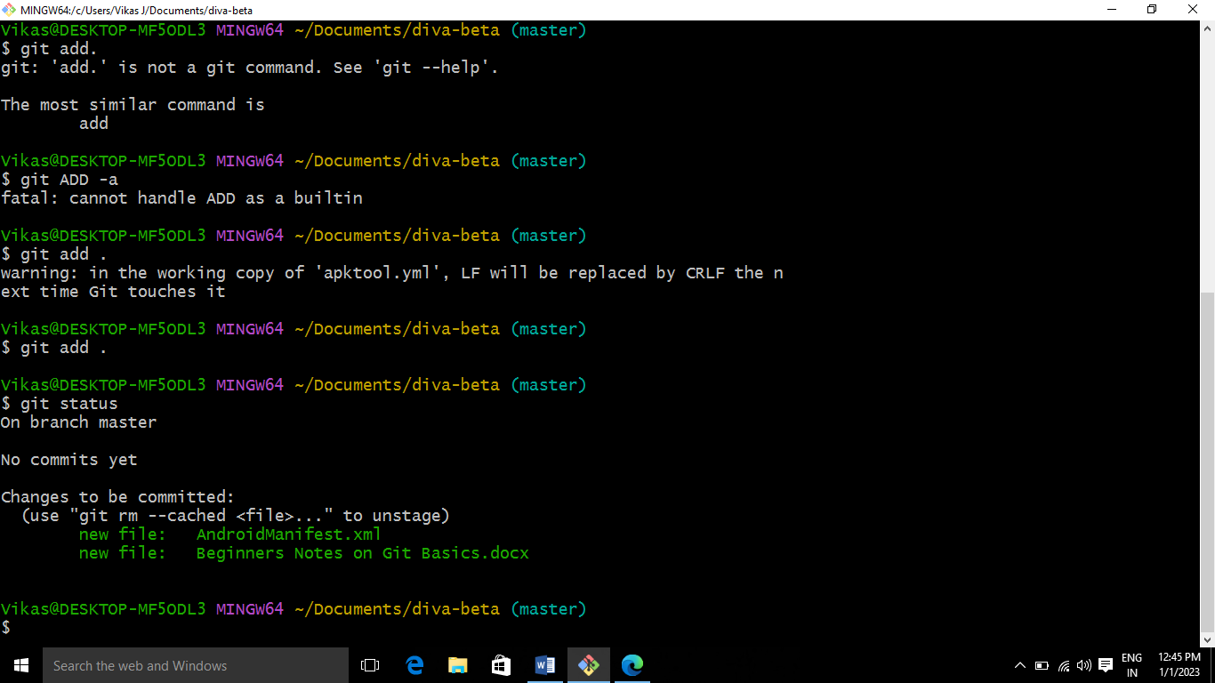

Again , view the status of the repository using git status



Git commit : It is used to record the changes in the repository.

* git commit –m <message>

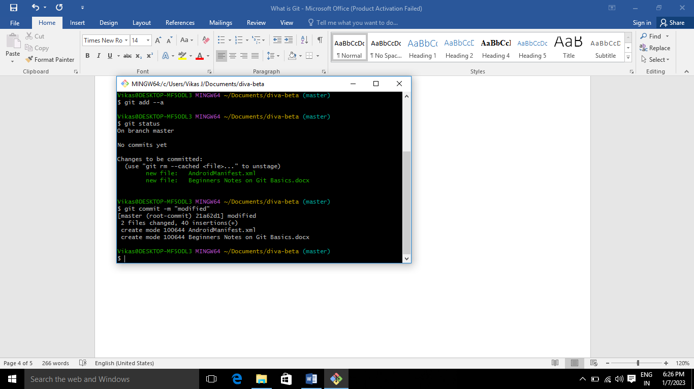

Git log : it is an utility tool to review and read a history of everything that happens to a repository.

* git log

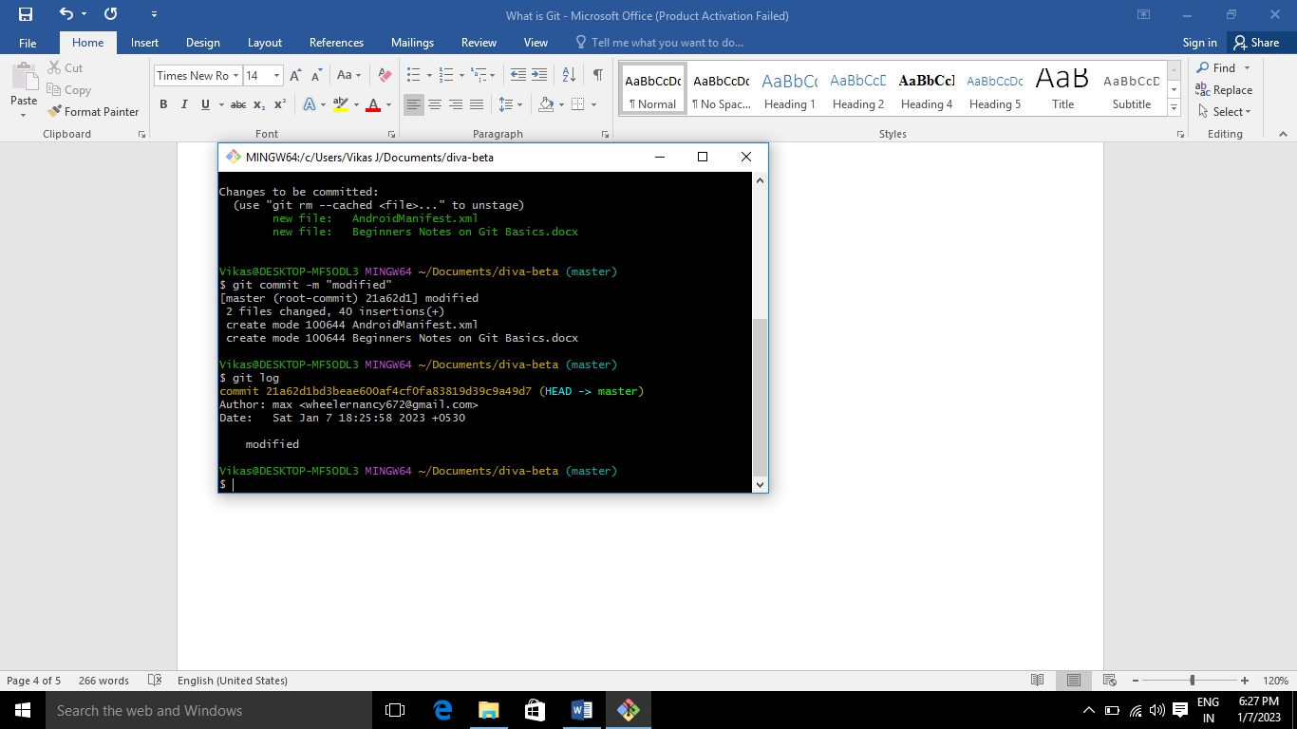

Now, go github create a repostiary and copy the link of the repositary

* Git remote add origin <repositary link>
* git remote add origin <https://github.com/nancy7899/max.git>

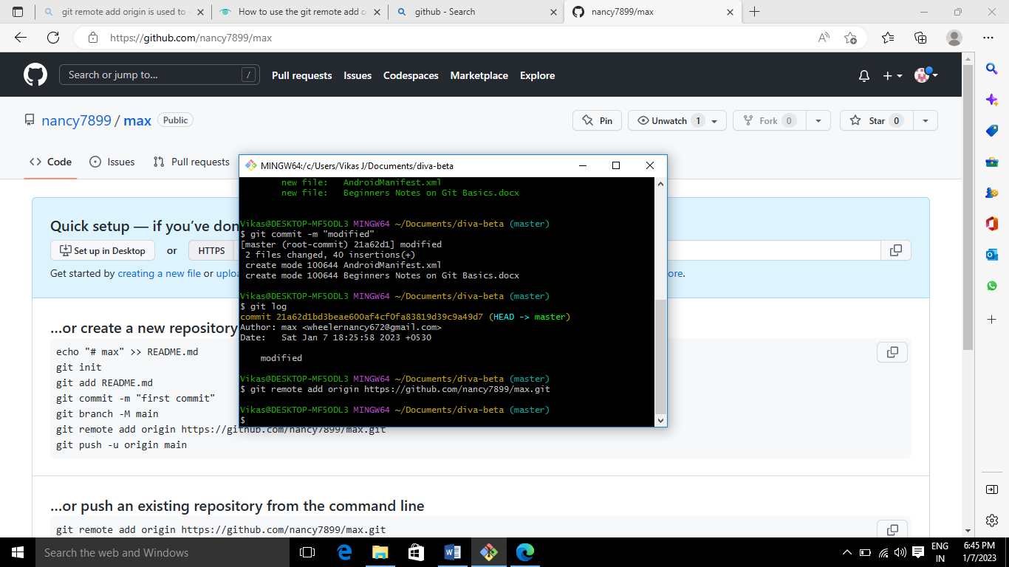

Git push : it is a command to upload all changes done from the local branches to the targeted remote repository.

* git push origin master

Git pull : The git pull command is used to pull a repository.

* git pull origin master

Git clone: The git clone is a git command, which creates a clone/copy of an existing repository into a new directory.

* git clone <url of repositary>
* git clone <https://github.com/nancy7899/max.git>

#### 

#### 